Project Design Phase-II
Data Flow Diagram & User Stories

Date | 31 January 2025
Team ID | LTVIP2026TMIDS36206
Project Name | Gemini Pro Financial Decoder: Transforming Complex Data into Actionable Insights
Maximum Marks | 4 Marks

Data Flow Diagrams:
A Data Flow Diagram (DFD) is a traditional visual representation of the information flows within a system. A neat and clear DFD can depict the right amount of the system requirement graphically. It shows how data enters and leaves the system, what changes the information, and where data is stored.

- User uploads CSV/Excel files (Balance Sheet, P&L, Cash Flow) to the Streamlit Web Interface.
- Streamlit App passes the files to the Data Processor (Pandas), which converts them into string format.
- Streamlit App sends the formatted text and specific prompts to the External API (Google Gemini 1.5 Flash).
- Google Gemini API processes the data and returns analytical summaries. 5. Streamlit App receives the summaries, extracts numeric data for charts, and displays the final dashboard to the User.

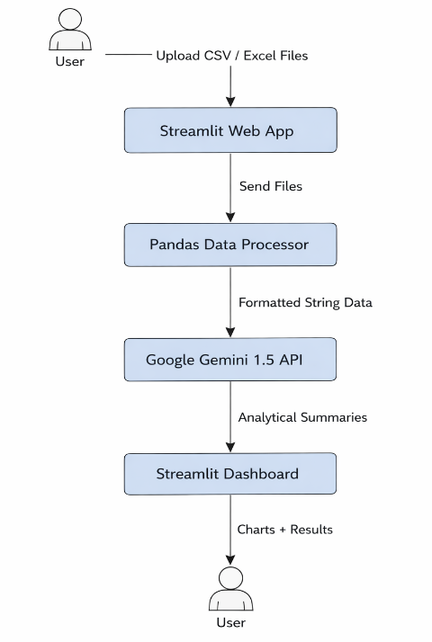

User Stories
Use the below template to list all the user stories for the product.
User Type | Functional Requirement (Epic) | User Story Number | User Story / Task | Acceptance criteria | Priority | Release
Customer (Web user) | Data Upload | USN-1 | As a user, I can upload my financial documents (CSV/Excel) so the system can analyze them. | File loads successfully and is read by pandas. | High | Sprint-1
Customer (Web user) | AI Analysis | USN-2 | As a user, I can click "Generate Reports" to receive an AI-generated summary of my financial data. | System returns a text summary for each uploaded file. | High | Sprint-1
Customer (Web user) | Error Handling | USN-3 | As a user, I want the system to handle API limits gracefully so my request doesn't fail permanently. | System pauses for 15 seconds and retries if a 429 error occurs. | Medium | Sprint-1
Customer (Web user) | Visualization | USN-4 | As a user, I can view dataframes and line charts of numeric data to quickly spot trends. | Charts render correctly on the UI beneath the summaries. | Low | Sprint-2

